Detailed Instructions:
In this activity we will investigate how long it takes to complete a Sudoku a puzzle. As a group you should already have decided upon what research questions are to be considered.
Step 1: In your lab booklet, record the research question/s to be considered.

Step 2: Access a stopwatch to record your time to complete the puzzle
You will need a stopwatch to time yourself. Just Google ‘stopwatch’ for an online stopwatch.

Step 3: Complete your allocated puzzle
Over the page is a Sudoku puzzle. Not everyone has the same puzzle, and the puzzles vary in difficulty. Once your stopwatch is ready, turn over the sheet, start the timer and complete the Sudoku.
Reminder: Each symbol has to appear exactly once in every row, once in every column and once in every box of 6.

Step 4: Record your data
When you’ve completed the puzzle, please go to the address
<insert short link to Google form for results submission here>
and complete the survey. There are two spaces for data on any additional variables that your class has decided to measure. Make sure you put the right response in the right question box!

Once you have completed the survey, you can access the raw data at the address
<insert short link to Google spreadsheet of results here>
Step 5: Have a think
While you’re waiting for others to finish, please try to think of any additional variables that could have impacted on the time to complete the puzzle. Note them down in your lab book (variables not measured) for your future reference. You should also note down, in your lab book, details of the variables measured.
(There is a strong possibility that today’s results will re-appear in future assessment tasks!)

Puzzle #1

Instructions:

The Greek letters α, β, δ, λ, ε, μ must appear once in each box, once in each row and once in each column. Use logic (I.e. do not guess) to determine what goes in each empty space.

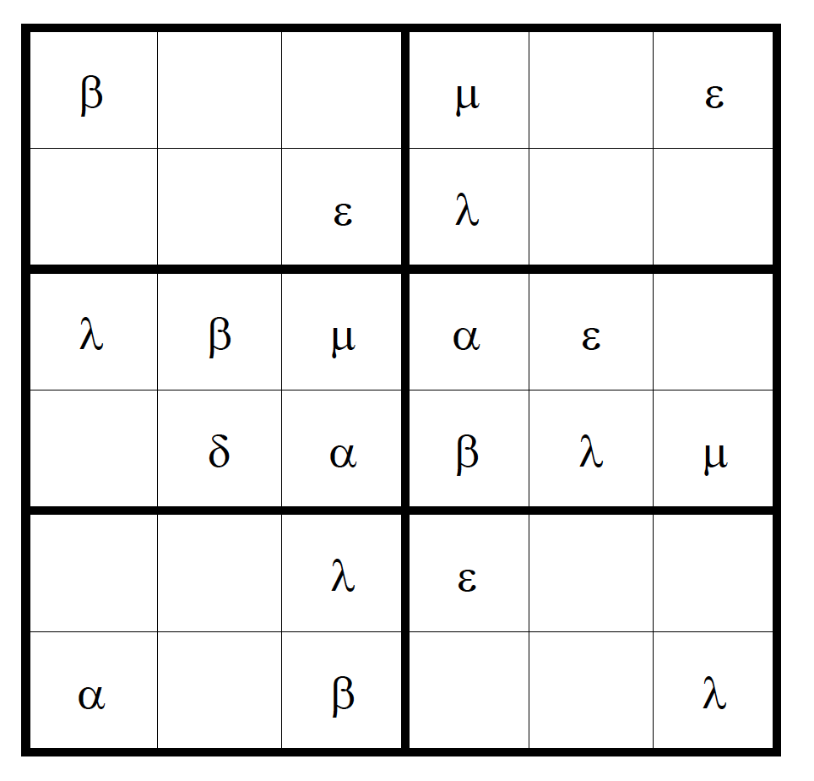

Time to completion: Minutes: Seconds:

Have you ever played Sudoku before today? Yes ☐ No ☐

Puzzle #2

Instructions:

The letters a, b, c, d, e, f must appear once in each box, once in each row and once in each column. Use logic (I.e. do not guess) to determine what goes in each empty space.

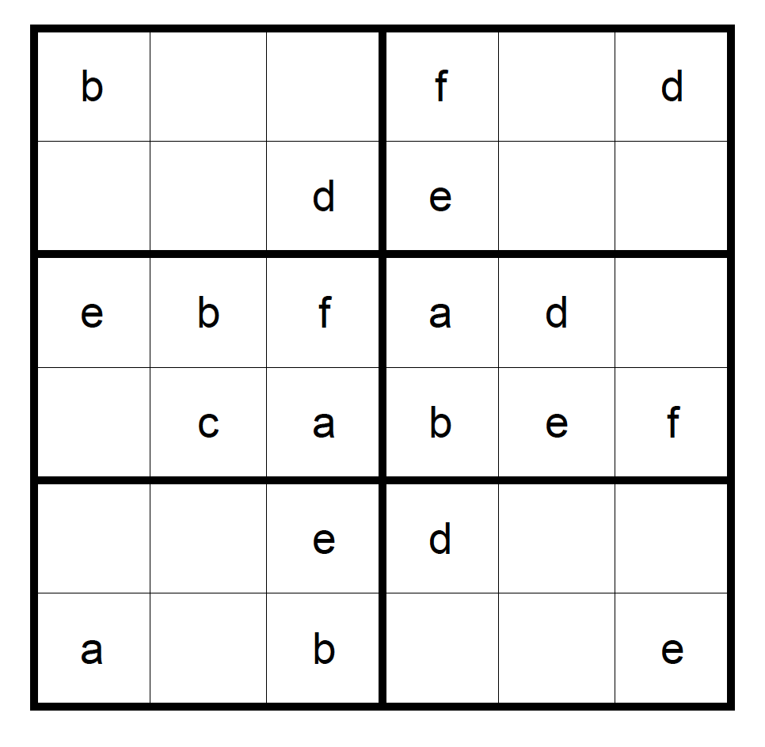

Time to completion: Minutes: Seconds:

Have you ever played Sudoku before today? Yes ☐ No ☐

Puzzle #3

Instructions:

The numbers 1, 2, 3, 4, 5, 6 must appear once in each box, once in each row and once in each column. Use logic (I.e. do not guess) to determine what goes in each empty space.

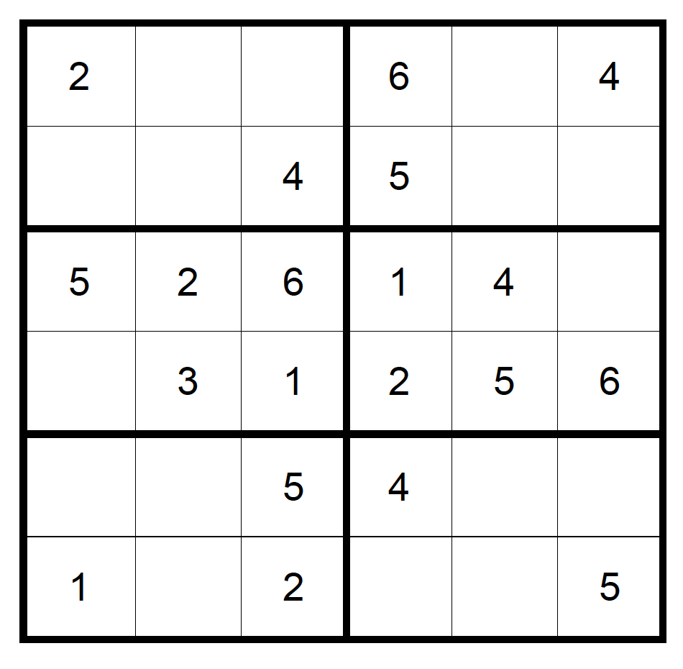

Time to completion: Minutes: Seconds:

Have you ever played Sudoku before today? Yes ☐ No ☐

Puzzle #4

Instructions:

The symbols   ✔ must appear once in each box, once in each row and once in each column. Use logic (I.e. do not guess) to determine what goes in each empty space.

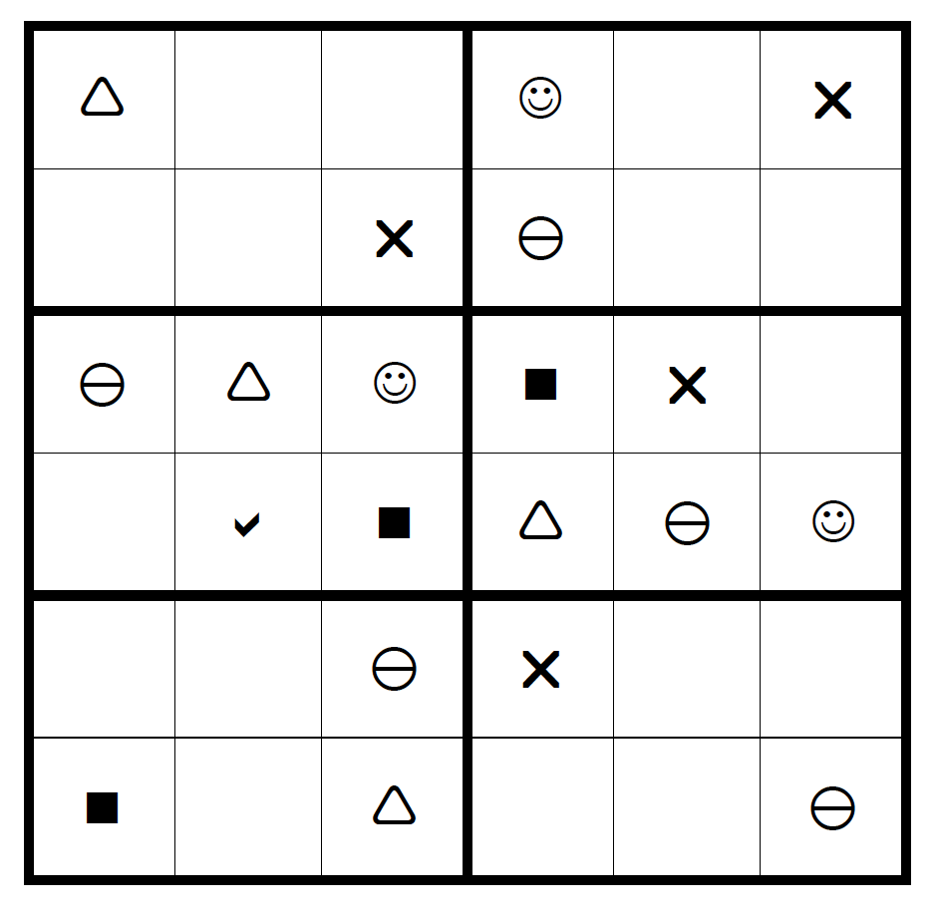

Time to completion: Minutes: Seconds:

Have you ever played Sudoku before today? Yes ☐ No ☐

